MAINTENANCE MANUAL
FOR
BOOM BARRIER

CLIENT: TATA PRIJECT LTD
PROJECT: ALSOTM
MFG.YEAR: -

DESIGNED, DEVELOPED & MARKETED
BY



G-BLOCK, 1ST FLOOR, THERMAX CHOWK
MIDC, ABOVE RENAULT SHOWROOM
CHINCHWAD, PUNE-411019

TEL.NO: - +912066304033
EMAIL:-info@nihva.com
www.nihva.com

BOOM BARRIER
SIZE | 6m & 8m
SR NO
CLIENT | TATA PROJECT LTD

ABTRACT:

We are pleased to forward this manual to you to provide guidelines on trouble free operation of the equipment, procedures for periodic and preventive maintenance, and troubleshooting. This manual consists of the description of equipment along with technical specifications, and operation procedures. For maintenance of ‘Bought-out’ equipment, please refer manufacturers’ manuals. We insist you to maintain necessary record (logbook) for ensuring proper preventive maintenance, to achieve trouble free production. We are sure; you will find this manual very useful and interesting. However, your suggestions and doubts if any are always welcome!

CONTENTS

- GA DRAWING

- FOUNDATION DRAWING

- ELECTRICAL CIRCUIT DIAGRAM

- SPARE & WEAR PART LIST

GA DRAWING: 6 MTR BOOM BARRIER

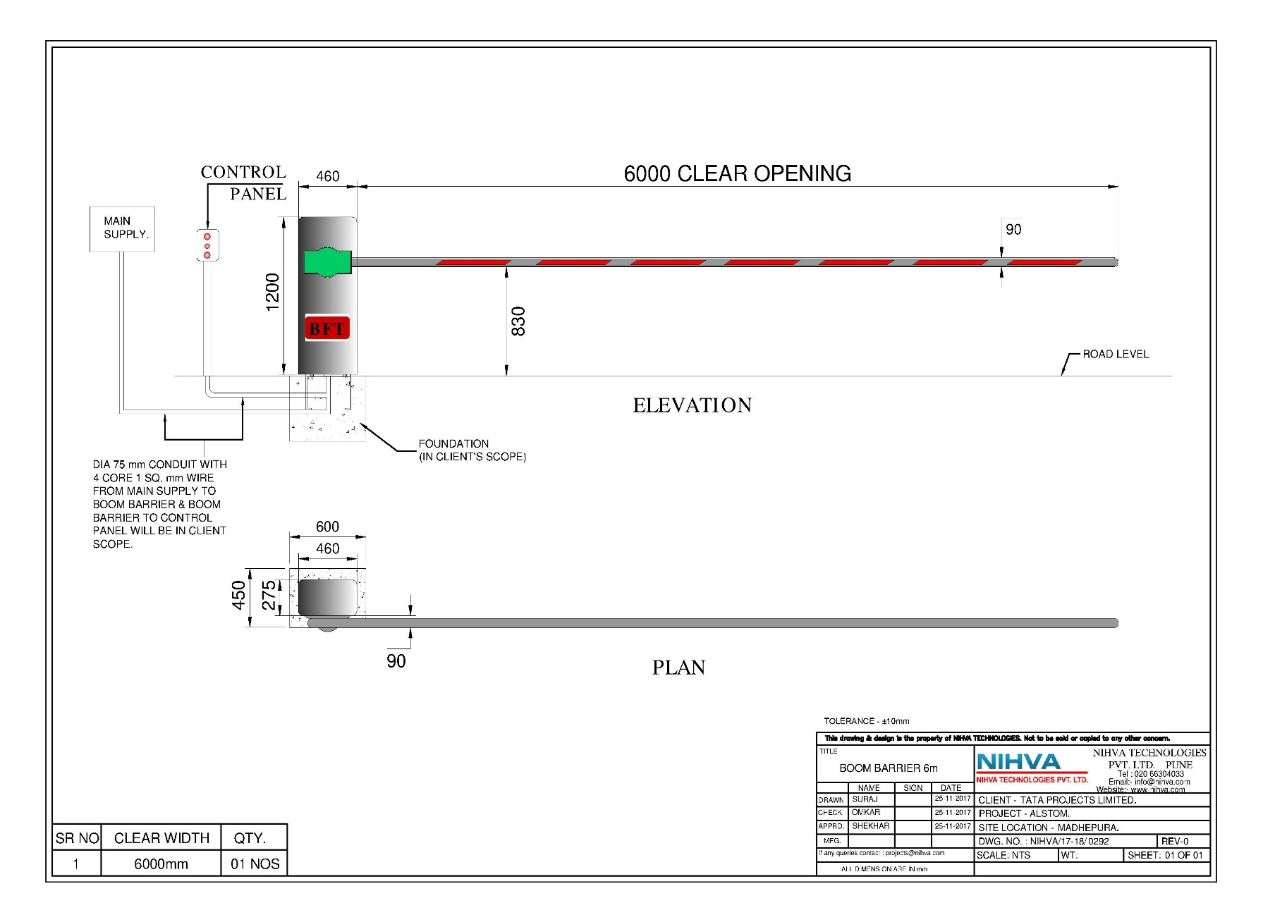
GA DRAWING: 8 MTR BOOM BARRIER

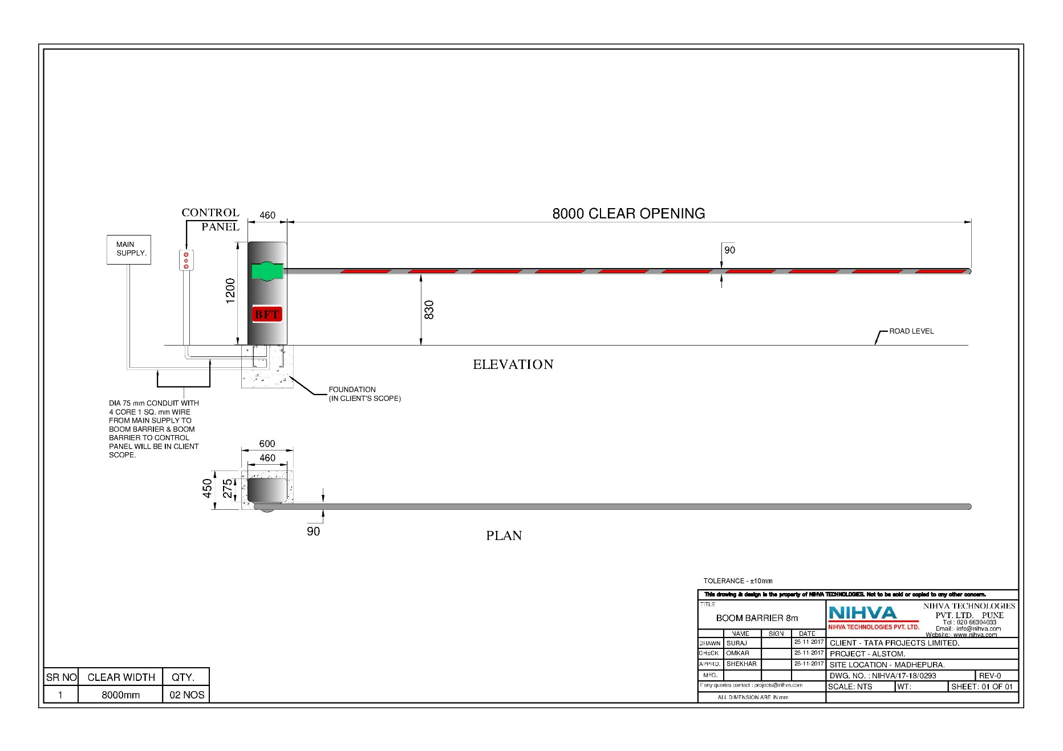
FOUNDATION DRAWING:

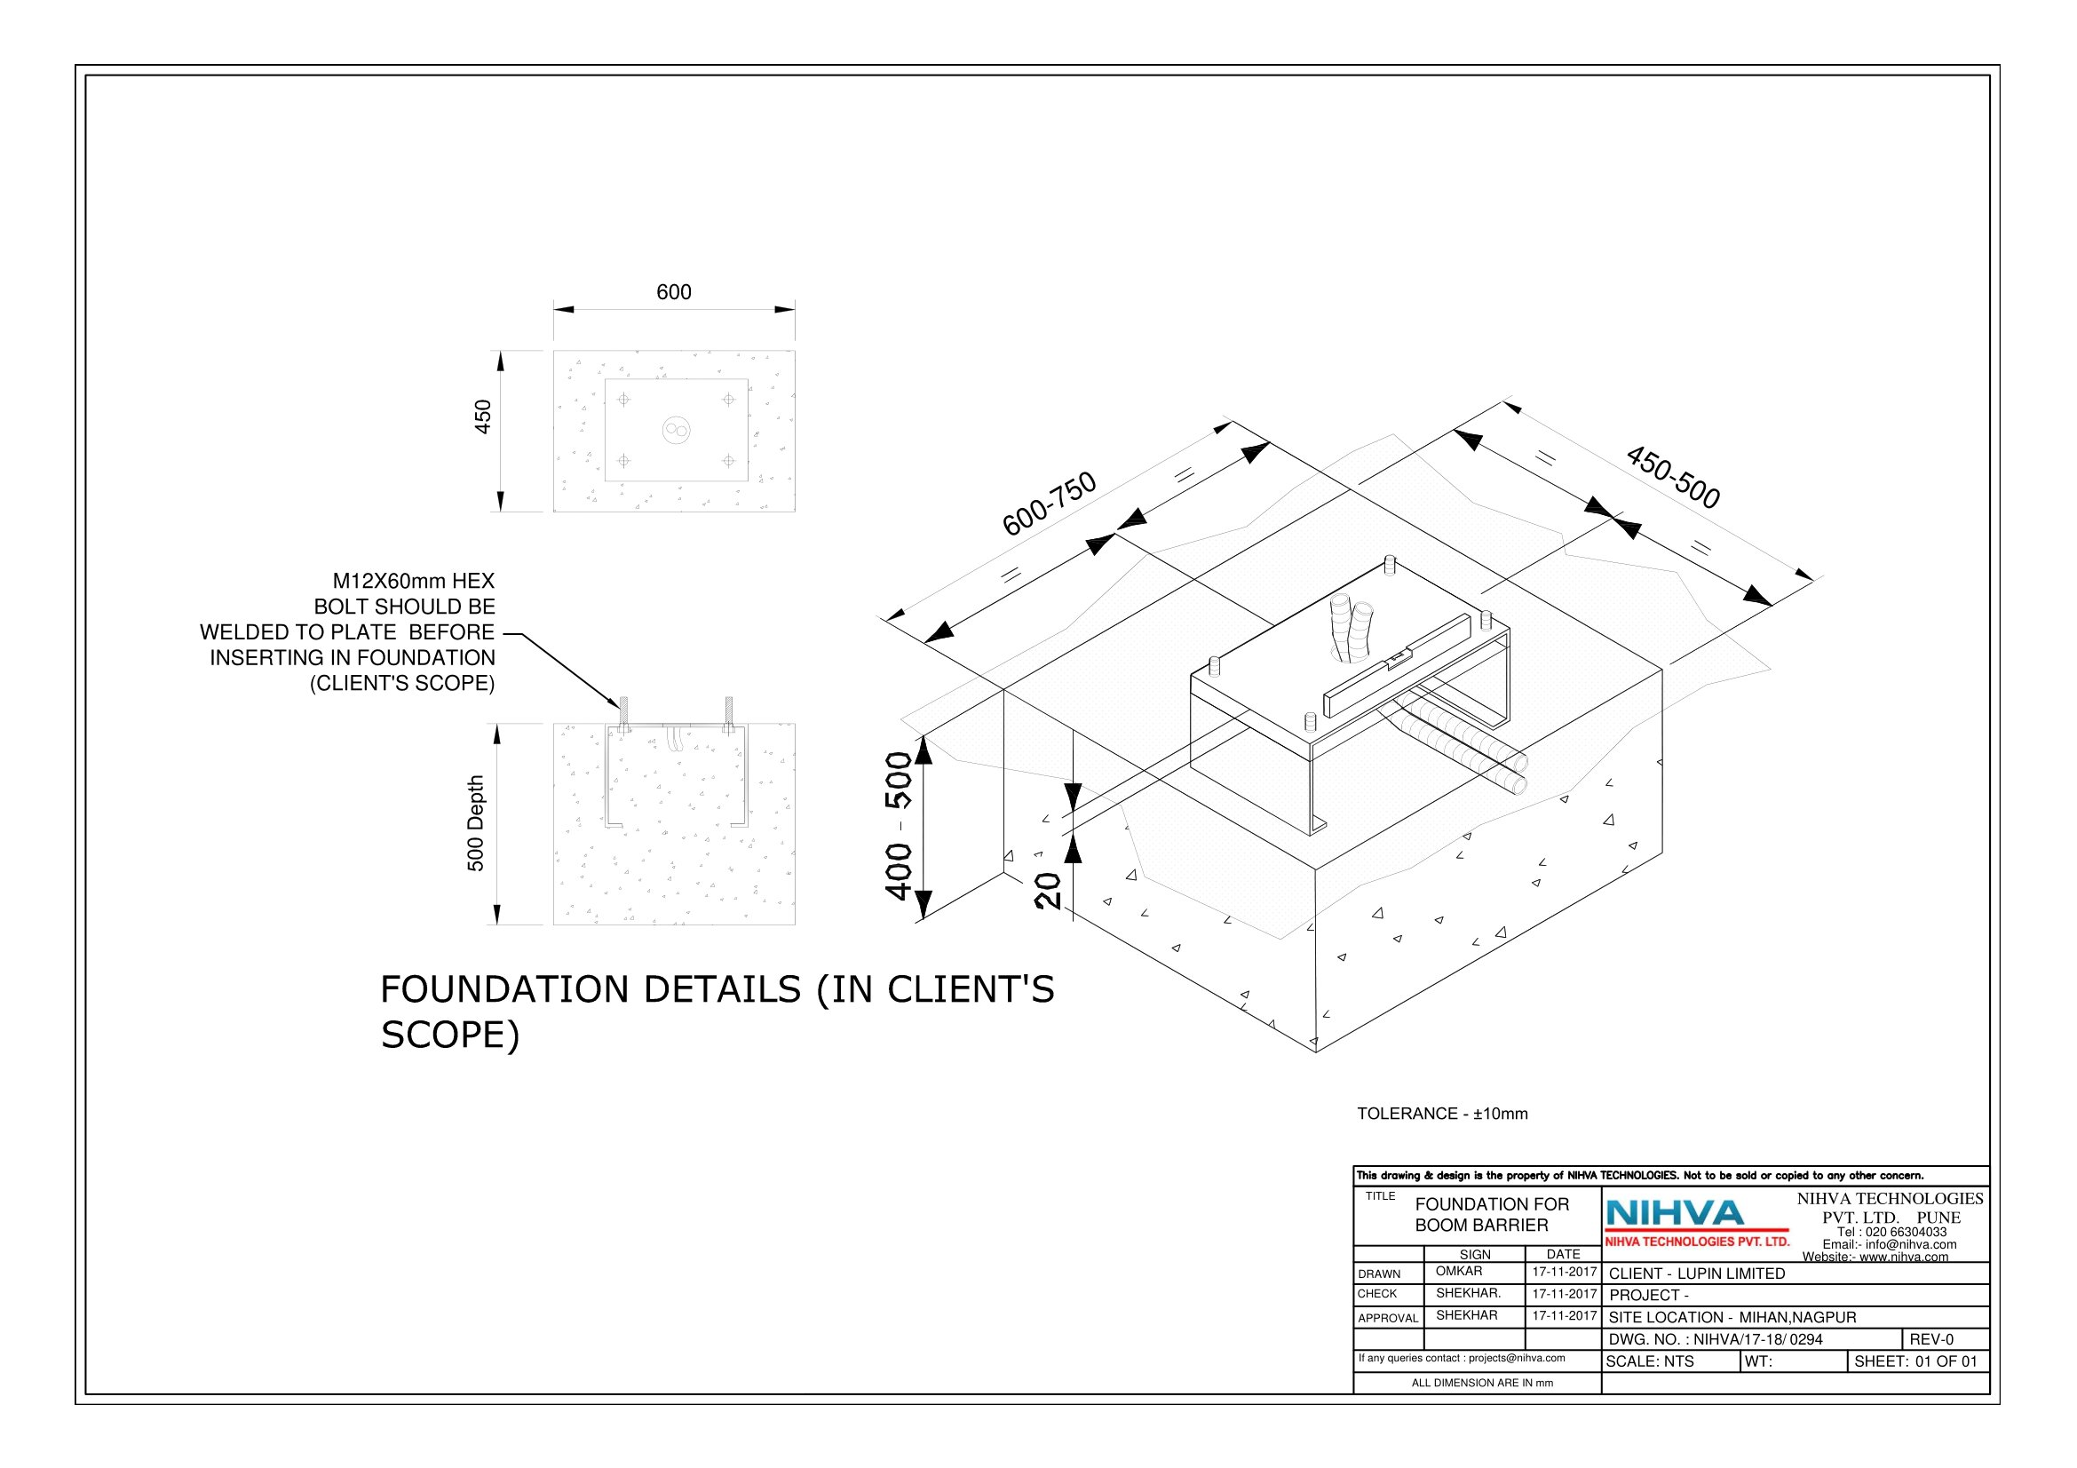
ELECTRICAL CIRCUIT DIAGRAM:

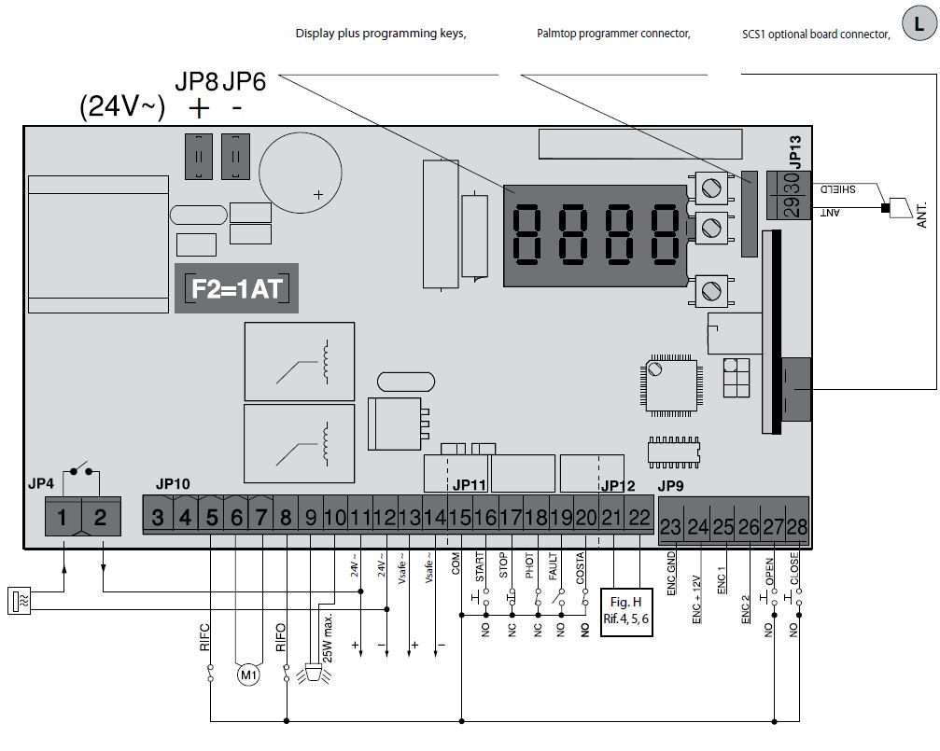
SPARE & WEAR PART LISTS:

S NO | ITEM DESCRIPTION | QTY.
1 | MOTOR | 1
2 | HINGE BRACKET | 1
3 | PUSH BUTTON PENDENT | 1

